Movie Box Office & Sequel Performance Analysis
Azim Tashpulatov | University of Evansville | R / RStudio | 2025
OVERVIEW
This project asks a simple question: do sequels earn more than original films, and does the gap hold up once a film’s budget, era, genre and release season are taken into account? I cleaned a public movie dataset, compared the two groups with descriptive statistics and visualizations, and used linear regression to estimate the sequel effect, then tested whether the model was reliable.
DATA AND METHOD
- Data: TMDb 5000 Movie Dataset (4,803 films). I kept English-language films released 1990–2016 with a budget and worldwide revenue of at least $1M, leaving 2,515 films (271 sequels, 2,244 originals).
- Defining a sequel: the dataset has no sequel field, so I built one. Films were grouped into series by title (for example, Iron Man 1–3), plus a few manual franchise groups such as Harry Potter and The Fast and the Furious. The first-released film in a series is an original and every later installment is a sequel. Reboots, remakes and ambiguous title matches (21 films) were dropped.
- Analysis: revenue is heavily skewed, so I modeled log(revenue). Three regressions add controls step by step: budget and release year, then genre and release season (summer, holiday). A sequel coefficient b means revenue is (e^b − 1) higher.
FINDINGS
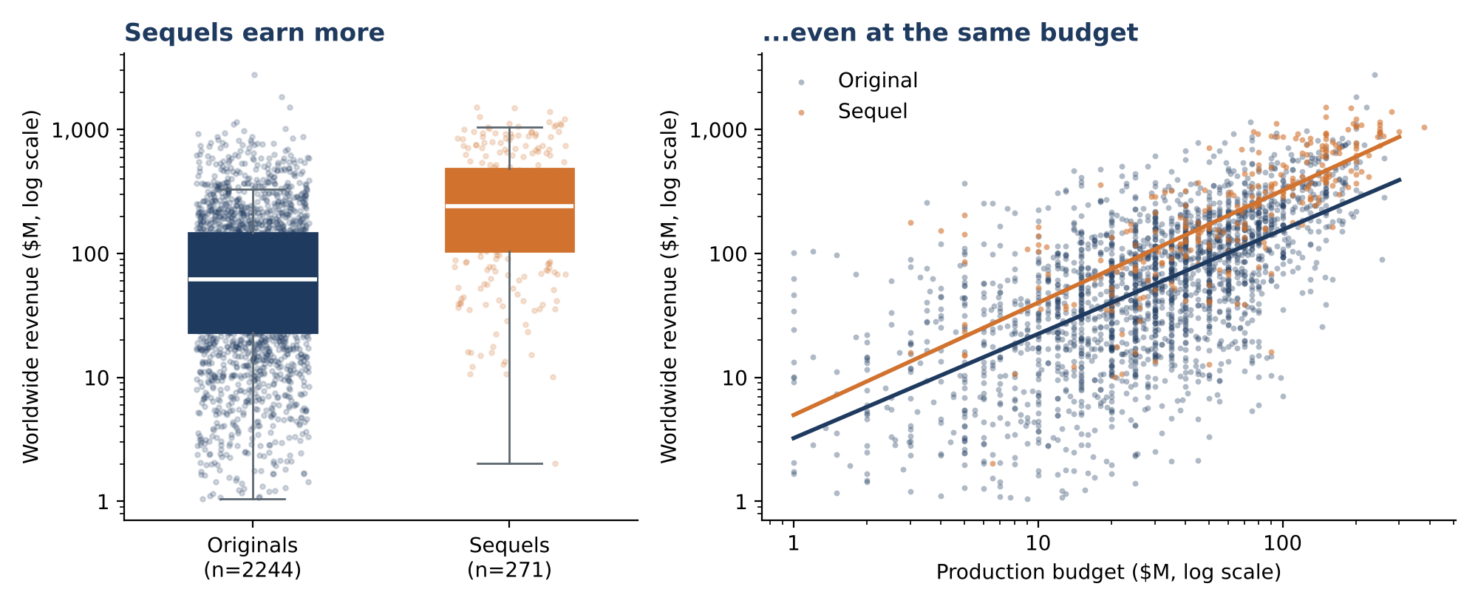
- Sequels earn about 4× as much on the surface. Median worldwide revenue was $240M for sequels versus $62M for originals (Mann–Whitney p < 0.001). But sequels also cost more to make: median budget $70M versus $30M.
- Most of the gap is budget, but not all of it. After controlling for budget, release year, genre and season, sequels still earned about 79% more (95% CI +61% to +99%). Budget alone explains most of the variation: a 1% larger budget is associated with about 0.84% more revenue.
- The premium shows up at every budget level. Median revenue for sequels was roughly 2× that of originals in the low-, mid- and high-budget thirds of films.
- Sequels are also safer bets. 94.5% of sequels earned more than their production budget, versus 74.7% of originals, and median revenue per budget dollar was 3.3× versus 2.1×. (Marketing costs are not in the data, so this overstates profit for both.)
- Other drivers: summer (+41%) and holiday (+35%) releases earn more than other months, and horror films outperform drama (+74%) at the same budget. Sequels also became more common over time: 6.9% of films in 1990–2002 versus 12.6% in 2003–2016.
Model | R² | Sequel effect on revenue | 95% confidence interval
1. Sequel only | 0.09 | +274% | +216% to +342%
2. + budget and release year | 0.46 | +97% | +72% to +125%
3. + genre and release season | 0.48 | +79% | +61% to +99% (robust SEs)
Sequel effect on revenue under each model. Model 3 uses heteroskedasticity-robust (HC3) standard errors.
MODEL CHECKS AND LIMITATIONS
- Fit and overfitting: Model 3 explains 48% of the variation in log revenue. On an 80/20 train/test split, test R² was 0.45 and test RMSE 0.99 versus 1.01 on training data, so the model is not overfitting.
- Assumptions: predictors were not collinear (all VIFs below 1.1) and no film had undue influence (largest Cook’s distance 0.009). Residual variance was uneven (Breusch–Pagan p < 0.001), so I report robust standard errors; the sequel result is unchanged.
- Limits: this shows association, not cause. Sequel status is my own classification, revenue is in nominal dollars (release year partly adjusts for inflation), the data ends in 2016, and sequels benefit from built-in audiences that a regression cannot separate from film quality.
FILES
movie_box_office_analysis.R (full analysis script), movie_analysis_data.csv (cleaned data with the sequel flag), and the figure above.

